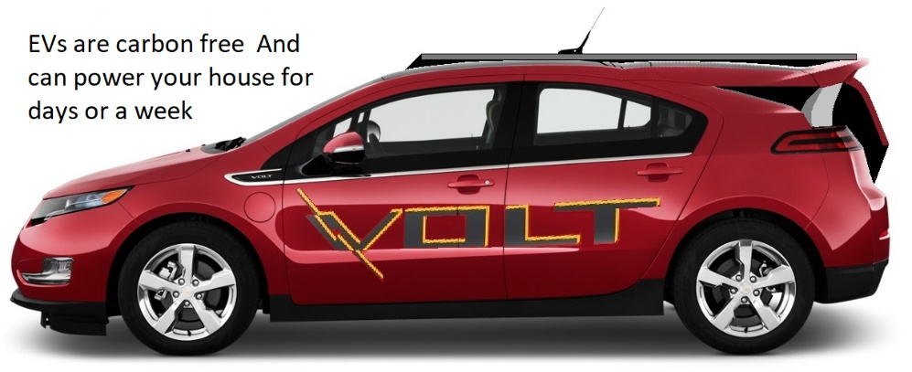
What can I do?
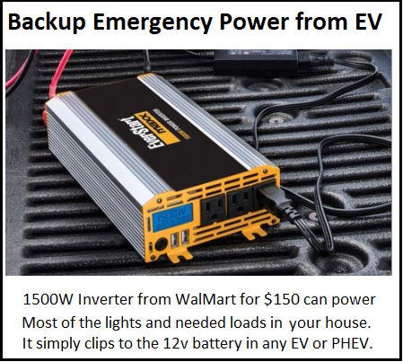
Often people ask about climate change, “what can I do”. A common response is “every little bit counts”. But actually, every little bit only counts very little. The one big thing that people can do with the largest impact is to be informed and prepared for their next car purchase. Burning gasoline is now the number one source of carbon emissions in the US and the easiest to fix. Sooner or later we need a replacement car and buying another gas burner, often under urgent need is the worst choice. A typical new car stays on the road for as many as 18 years before finally meeting its demise in a junkyard. A new gas car bought today will still be spewing toxic emissions through 2039 long past the point of no-return for our climate. Its time to change!
Emergency Power: Coincidentally with increasing storms due to climate change and resulting power outages sometimes affecting hundreds of thousands, another advantage of EV’s is their huge energy storage capacity. This capacity can be used during power outages to power critical needs in a home for days to a week. Just clipping a $150 inverter (available from any hardware store) to the car’s 12v battery can provide this power easily and independent of car make and model
(See http://aprs.org/FrankenVolt.html)
With 67 models of EVs and plugin-hybrids now on the market and half costing less (with incentives) than a gas car and more than half having ranges over 350 miles, it is a good idea to consider one that is right for you. When charged from renewable energy available from most utilities, these cars offer a 100% carbon free transportation. Even when charged from a local dirty grid, they have been shown to still result in 70% less carbon.
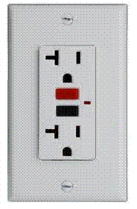
Charging from 120 V or 240 V: Many will prefer a plugi-hybrid which has plenty of daily EV mileage (30 to 40 miles) and yet has a backup gas engine for longer trips (hundreds of miles) as needed. All EV’s can be charged from any standard 120v outlet overnight for the average American daily 40 mile usage. But longer range EV owners usually purchase a faster 240 V charge cord for a few hundred dollars that can also charge a 250 mile EV overnight .
We are now ten years into the modern EV revolution and the switch to EVs is happening. The sales of gas cars are waning since the fall of 2018 and the sales of EV’s is growing exponentially. Its time to be on the right side of history and time to re-think our long held grasp on fossil fueled vehicles and be prepared for our next such major energy decision.
Bob Bruninga, PE - Author http://aprs.org/Energy-Choices’html

